**MINOR PROJECT-I**

**SYNOPSIS**

**ON**

**Automated Story Teller – Dictionary Based**

**Submitted By**

|  |  |  |  |
| --- | --- | --- | --- |
| Sanyam Jain | Shivani sharma | Sonaal Kalra |  |
| 500046658 | 500046544 | 500046848 |  |
|  |  |  |  |

***Under the guidance of***

**Dr. Hitesh Kumar Sharma**

**Assistant Professor**

Department of Analytics



**School of Computer Science and Engineering,**

**College of Engineering Studies,**

**UNIVERSITY OF PETROLEUM AND ENERGY STUDIES**

**Dehradun-248007**

**2017**

AUTOMATIC STORY GENERATOR

ABSTRACT-

Content production is one of the major barrier in the industry. Whether in development of websites, videogames or movies, company employs a large number of content provider and screen writers. So for these reasons, building the automatic story generator has been one of the big dream in the modern era. This project aim is to create an automatic story generator. Actually there are many systems that aims to create new stories automatically. All of these system uses different methodology and usually they are difficult to compare. Objective is to make a Automated story generator using some predefines Subject +verb + object. We try to make our program learn for the Grammar syntaxes for some genre specific generation Objective is to produce original and random content each time and a in very less time.

INTRODUCTION-

The term automatic story generator refers to computational procedure resulting in work that can be considered a story. This topic has been a subject of research for over fifty years. An algorithm is understood as a set of instructions that, when applied to given input produces an output. In this present context the desired output is story. This project is related to the problem of computational creativity, how to create something new and useful at the same time. In order to build an automatic story generator some of the theory is necessary as a basis of this project. Research on this has experienced considerable growth over the years.

Objective is to produce original and random content each time. And in very less time. Also it is very first try to make ASG using C language, need to embed several libraries available for word parsing, word predictions, grammar libraries, word base etc. Story generator systems are clearly at an early stage of development. The ﬁrst storytelling system on record is the Novel Writer system, developed by Sheldon Klein (Klein et al. 1973). Novel Writer created murder stories in a weekend party setting. This system is reputed to have generated “2100-word murder mystery stories, complete with deep structure, in less than 19 seconds.” Further many of the research has been done on automatic story generator. So this project’s main motive is to apply the engineering principal when designing and constructing such systems for the further development of such technology.

Problem statement

1. Thinking about some stories and mind but not able to make or complete it
2. Making any random content or write any content just by having keywords is not easy
3. Content generation automatically is very difficult and always been very hot topic since 60s.
4. Writing papers, genre specific content, Narrating, Natural language generation are major aspects of AI.

LITERATURE REVIEW:

|  |  |  |  |
| --- | --- | --- | --- |
| REFERENCE | AUTHOR | KEY FINDINGS | COMMENTS |
| [1] | Y Shim ,M KIM | generate consistent stories using autonomous characters  have multi-level goals: viewer goals, plot goals, and character goals  A Model for Generating Consistent Episodes | According to this to construct an interactive narration, it use multi-level goals: viewer goals, plot goals, and character goals. The character goal is used to make believable and emotional characters. The plot goal is used to generate a consistent story. The viewer goal is used to interact with users. |
| [2] | CD Newell, Md wood | A method and system for automatically creating an image product based on assets stored in a user database  obtaining a plurality of digital media files associated with an event;  automatically classifying the event based on analyzing said plurality of digital media files; | A number of stored digital media files are analyzed to determine their semantic relationship to an event and are classified according to requirements and semantic rules for generating the image product. |
| [3] | Neil McIntyre and Mirella Lapata | A data-driven approach for generating short children’s stories that does not require extensive manual involvement.  System follows a generate-and-and-rank approach  Stories generated by the random, deterministic, and rank-based systems. | It proposed a novel method to computational story telling. This approach has three key features. Firstly, story plot is created dynamically. Secondly, generator realizes the various components of the generation pipeline. Thirdly, it generate and store multiple stories efficiently in a tree data structure. |
| [4] | P Gervas | Only narrate the main events of the plot  System operates with a representation in Description Logics, combining stored fabulas with the narrative knowledge implemented in a domain-specific ontology.  utility of the system in terms of quality and originality of the generated artifact | The aim of our project is to generate creatively new basic stories. This deals with how to create more useful and new at the same time. Content production is being done using theories in the field of Narratology |
| [5] | A Hong, C Solis, JT Siy, E Tabirao | Natural language generation, story generation, story planning operators, story tree, semantic ontology  Picture Books is an automated story generation system | THE PICTURE BOOKS SYSTEM Picture Books is an automated story generation system intended for children age four to six. It derives the story elements from a given input picture with components selected by the user from a library of background images, character stickers and object stickers |

Conclusion of Literature Review:

From the above research papers, it is concluded that:

[1] Generate consistent stories using autonomous characters

[2] System for automatically creating an image product based on assets stored in a user database.

[3] System follows a generate-and-and-rank approach.

[4] Content production is being done using theories in the field of Narratology

[5] Picture Books is an automated story generation system using images as input.

**Methodology**

Existing versions of ASG work on principle of the word data sets, story sets. The program workflow:

1. Program will be trained for the keywords, subjects, objects and all real world entities.
2. Those keywords are coded such that it makes fresh, real and original content every time.
3. Several algorithms for making random generations, string related algorithms, time calculation algorithms etc will be used for making our program more efficient each time of use.
4. Automated story generator will use some predefines Subject+verb+object.

**Flow Chart**

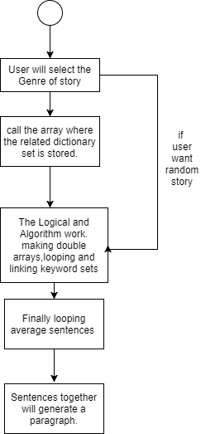

**PERT CHART**

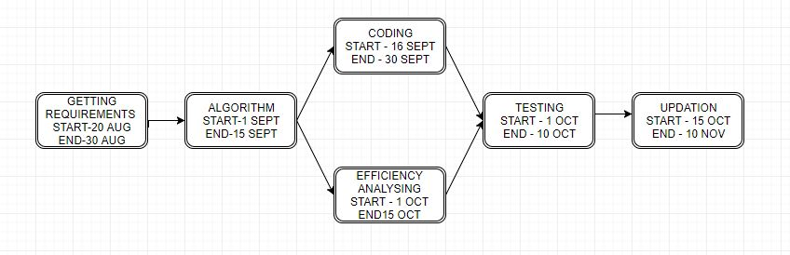

**System Requirements: (Software/Hardware)**

* Linux origin OS (our system is Ubuntu 16.04 LTS)
* Gcc compiler (sudo apt-get install gcc)
* Vim/vi
* Stdlib, strings and other header files
* And remaining basic requiements.

**REFERENCES:**

[1] Hong, A., Solis, C., Siy, J. T., Tabirao, E., & Ong, E. (2008). Picture books: Automated story generator. *Undergraduate Thesis, De La Salle University, Manila, Philipian*

[2] Shim, Yunju, and Minkoo Kim. "Automatic short story generator based on autonomous agents." *Intelligent Agents and Multi-Agent Systems* (2002): 561-568.

[3] Newell, Catherine D., et al. "Automatic story creation using semantic classifiers for images and associated Meta data." U.S. Patent Application No. 11/758,358.

**Approved By**

**Dr. Hitesh Kumar Sharma (Name & Sign)**

**Project Guide Department Head**